Student: Steve Patterson 
Contact Phone: 248.783.6493
Contact Home E-mail: hybridcalibratorsrule@gmail.com
Contact Student E-mail: steven.patterson@csuglobal.edu
Course Section: 25FD-CSC500-1 – Principles of Programming
GitHub URL:
Assignment: Module 7: Portfolio Milestone
DATE: 11/23/25

Creating Python Programs (Program Requirements)
Write a program that creates a dictionary containing course numbers and the room numbers of the rooms where the courses meet. The dictionary should have the following key-value pairs:
Key-Value Pairs: Room Number
Course Number (key) | Room Number (value)
CSC101 | 3004
CSC102 | 4501
CSC103 | 6755
NET110 | 1244
COM241 | 1411
The program should also create a dictionary containing course numbers and the names of the instructors that teach each course. The dictionary should have the following key-value pairs:
Key-Value Pairs: Instructors
Course Number (key) | Instructor (value)
CSC101 | Haynes
CSC102 | Alvarado
CSC103 | Rich
NET110 | Burke
COM241 | Lee
The program should also create a dictionary containing course numbers and the meeting times of each course. The dictionary should have the following key-value pairs:
Key-Value Pairs: Meeting Time
Course Number (key) | Meeting Time (value)
CSC101 | 8:00 a.m.
CSC102 | 9:00 a.m.
CSC103 | 10:00 a.m.
NET110 | 11:00 a.m.
COM241 | 1:00 p.m.
The program should let the user enter a course number and then it should display the course's room number, instructor, and meeting time.

Submission:
Compile and submit your pseudocode, source code, and screenshots of the application executing the code, the results and GIT repository in a single document (Word is preferred).

PSEUDOCODE:
def course_number_room(): create a method with a dictionary to store the course number vs room number
def course_number_instructor(): create a method with a dictionary to store the course number vs the instructor
def course_number_time(): create a method with a dictionary to store the course number vs the start time.

def main():
DISPLAY the courses available
WHILE Loop: allows for repeating course requests and q for quit
ENTER user enter the course they would like to know room, instructor and time
TRY:
EXTRACT the information out of the course with the call to the dictionaries
PRINT: course number
PRINT: room
PRINT: instructor
PRINT: time
EXCEPT:
PRINT: Error not matching of the existing classes
MAIN

SOURCE CODE LISTING:
#Student: Steve Patterson
#Contact Phone: 248.783.6493
#Contact School E-mail: hybridcalibratorsrule@gmail.com
#Contact Student E-mail: steven.patterson@csuglobal.edu
#Course Section: 25FD-CSC500-1 – Principles of Programming
#Course Module: Critical Thinking Module 7
# dictionary in a method to save the course and room number
def course_number_room():
course_rooms = {
"CSC101": 3004,
"CSC102": 4501,
"CSC103": 6755,
"NET110": 1244,
"COM241": 1411
}
return course_rooms
# dictionary in a method to save the course and instructor name
def course_number_instructor():
course_instructors = {
"CSC101": "Haynes",
"CSC102": "Alvarado",
"CSC103": "Rich",
"NET110": "Burke",
"COM241": "Lee"
}
return course_instructors
# dictionary in a method to save the course and the starting time
def course_number_time():
course_times = {
"CSC101": "8:00 a.m.",
"CSC102": "9:00 a.m.",
"CSC103": "10:00 a.m.",
"NET110": "11:00 a.m.",
"COM241": "1:00 p.m."
}
return course_times
def main():
# call the methods and have the dictionary in a local copy
rooms = course_number_room()
instructors = course_number_instructor()
times = course_number_time()
# display the courses available for the user to choose from
print("Please enter one of the following courses:")
for course in rooms.keys():
print(course)
# continue to loop to allow for multiple entries
while True:
course_input = input("Enter a course number from the list provided: (or enter 'q' to quit)").upper()
# if the user want to quit break the loop
if course_input == "Q":
print("Thank You and have a Great Semester!")
break
try:
# grab the room, instructor and time from the dictionaries
room = rooms[course_input]
instructor = instructors[course_input]
time = times[course_input]
# print the requested information
print("\nRequested Course Information")
print(f"Course Number: {course_input}")
print(f"Course Room: {room}")
print(f"Course Instructor: {instructor}")
print(f"Course Meeting Time: {time}")
print("Have a great course!")
# have an exception incase the user does not enter an available course
except KeyError:
print("\nError: This course could not be found, please try again.")
# the main
if __name__ == "__main__":
main()

SCREENSHOT OF APPLICATION WORKING:

Both these are examples of good inputs meaning the courses are on the list

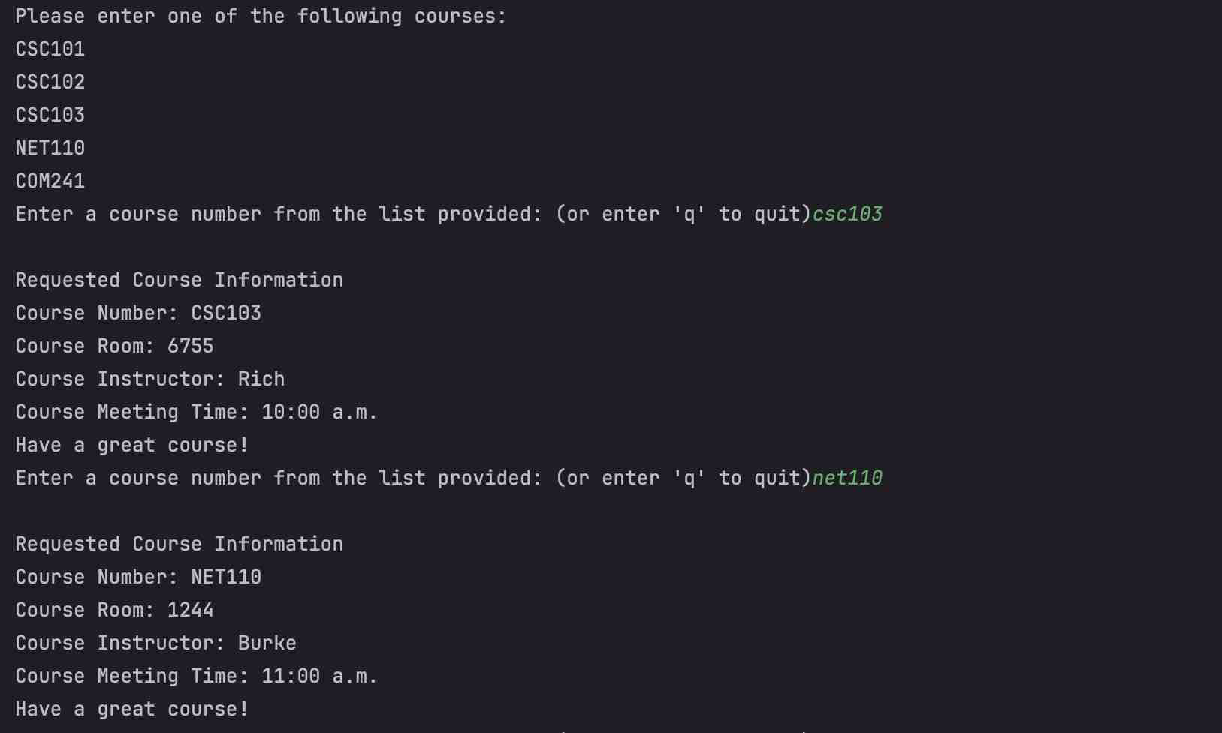

Below is an example of a wrong course number entered and an Error message.
The next command was the option to quit and the program exited the main loop

